DBMS LAB5
Anmol Keswani_ECS_D6-68
Aim: To Implement of Data Insertion, View Creation, and Multi-Table Join Operations in SQL
Q1. Insert new player Michale Clark with player ID 300311 in the table player.

Q2. Insert new player Sam from India , Ahemdabad with player ID 406317 in the table player.

Q3. Creating View for Batsman.
CREATE VIEW Batsman (PID,FName,LName,Country,MID,Score)
AS SELECT PlayerID,FName,LName,Country,MatchID,NRuns
FROM Player,Batting
WHERE PlayerID=PID;
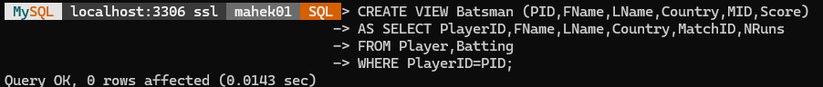

select * from Batsman;
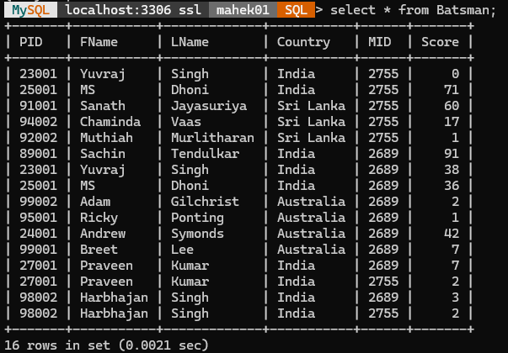

Q4. Creating View for Bowling.
CREATE VIEW Bowling2689 (PID,FName,LName,Country,NOvers,NWickets)
AS SELECT PlayerID,FName,LName,Country,NOvers,NWickets
FROM Player,Bowling
WHERE PlayerID=PID
AND MatchID=2689;
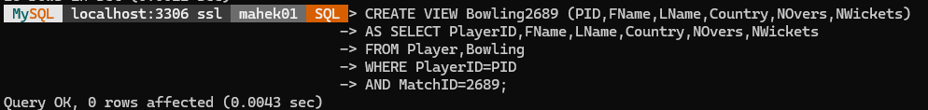
select * from Bowling2689;
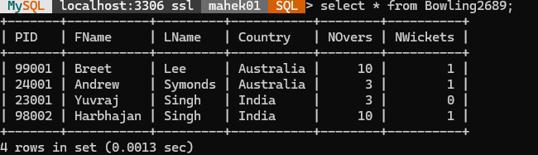
Q5. Find name of all players who have scored 60 or more runs.
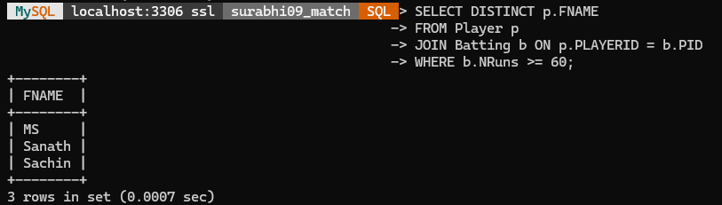
Q6. Find the names of bowlers that have not taken any wickets in ODI match 2689 .
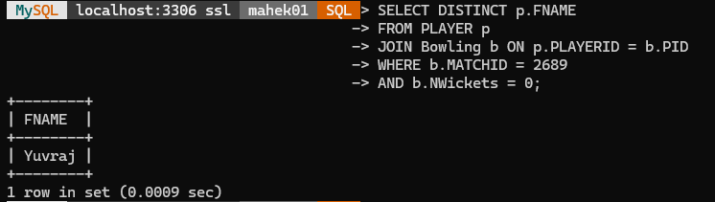

Q7. Define a view NPlayer for obtaining the names of the countries & number of players from each country.
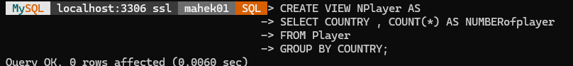
SELECT * FROM NPlayer ;
